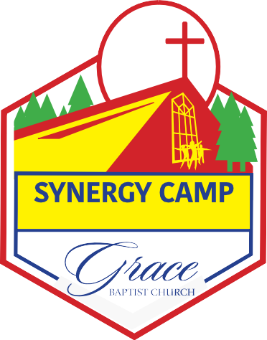
2176 Walling Road
2023
Springfield, TN 37172

2023 Synergy Camp
Employment Application

Applicant Information

Full Name
Last First M.I.
Date

Address
Street Address Apart-
ment/Unit

City State Zip

Phone Email
I am interested in working:
Full Time: Monday-Friday 7:30 AM – 4:30 PM

Part Time: Week 1 Mon/Wed/Fri 7:30 AM – 4:30 PM
Week 2 Tues/Thurs 7:30 AM – 4:30 PM

Education Level:
Masters Degree/Certified Educator
Bachelors Degree/Certified Educator
Bachelors Degree/Non-Certified Educator
Bachelors Degree/Non-Certified Educator
High School Diploma/GED

