Synergy Summer Camp Registration Form

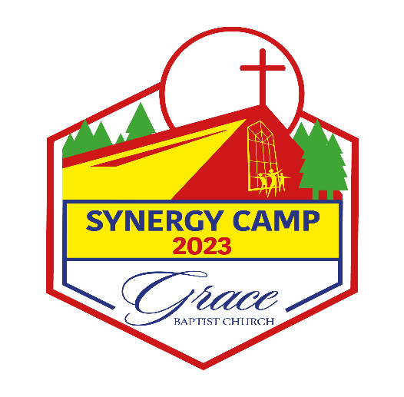

Please fill out the Synergy Camp Registration Form to enroll your child in summer camp. If you have more than one child, you must fill out a separate form for each.

Tuition for Synergy Summer Camp will be $700.00 per child for the entire summer.** There is a
$100 non-refundable deposit due upon registration. $600 Balance is due by May 22, 2023. If payment is not received, your child's spot is not guaranteed.

**Tuition does not include fees for optional Field Trips or any on-campus water days.

* Required

1.

________________________________________________

___________________________________________________
___________________________________________________

5. ______________________

6.

_____________

7.

_______________________________
Example: January 7, 2019

8.

Mark only one oval.

Male Female

9.

10.

.

Please fill out your information below.

11.

12.

______________________________________________

13.

Cell Phone

_________________________________________________________________

Please fill out your information below.

Cell Phone
_________________________________

Email
_________________________________________

These people will also be on the authorized list for picking up or dropping off your child.

Parent’s Signature

_____________________________________________________________________

